# **Design and develop an attractive and innovative mobile holder, to use mobile phones on study table.**

**Name of students USN**

1. APARNA A PATIL 1MJ21CS021
2. KRUTHIKA H.S 1MJ21CS093
3. MAHI NARESH HEGDE 1MJ21CS104
4. SUPREETHA VIKRAM 1MJ21CS219

# **ABSTRACT**

There are instances when you need to keep your phone in place, but it may not be in your pocket or backpack. This is where the phone stand comes in! It allows you to place your device anywhere at any Angle, and it’s a very comfortable experience. The phone stand provides a more stable and comfortable place to hold your phone and makes it easier to do more with it. In today’s technologically advanced world, most of us rely on our phones for everything from entertainment to work. A phone stand can simplify tasks such as video conferencing with loved ones or browsing at work. These items are designed to prop up your mobile device so you can watch videos, scroll through pictures, and keep it clean.

In this list, we list all the scenarios in which a phone stand or holder is useful. Multitasking when working on projects: You can easily watch two devices at the same time with a phone stand if you’re a student or a professional with lots of work to do. The Walla box has been designed to fit right on the wall of public bathrooms, so people don’t need to worry about dropping their phones on the toilet. You can play your Spotify playlist and follow the GPS without fuss, thanks to a phone mount that keeps your device in view while keeping your hands on the wheel.

If you don’t have a television or if you want to listen to a podcast while in bed, a clip-on holder can be attached directly to your headboard so that you can watch videos while you sleep. Next time you want to try a new dish, hold your phone in the holder and watch a video while cleaning your pots and pans. A handle holder allows you to easily see your grocery list without bumping into other people as you push a cart around the store. Our product is economic and it is long lasting compared to the other products present in today’s market.

Table of Contents

**[Design and develop an attractive and innovative mobile holder, to use mobile phones on study table](#_Toc119661454)**[…………………………………………………………………………………………………….1](#_Toc119661454)

[**ABSTRACT** 2](#_Toc119661455)

[**Chapter 1** 5](#_Toc119661456)

[**Introduction** 6](#_Toc119661457)

[**1.1 Introduction** 6](#_Toc119661458)

[**Chapter 2** 10](#_Toc119661459)

[**Literature Survey** 11](#_Toc119661460)

[**Table 2.1 Literature Survey** 11](#_Toc119661461)

[**2.2 Literature Summary** 1](#_Toc119661462)7

[**Chapter 3** 1](#_Toc119661465)9

[**Methodology**](#_Toc119661466) 20

[**Figure 3.1 Side View** 2](file:///C:\Users\kbruc\OneDrive\Documents\REPORT%20ON%20WASTE%20CLOTH.docx#_Toc119661468)0

[**Figure 3.2 Top View** 2](#_Toc119661469)1

[**Figure 3.3 Front and Side View** 2](#_Toc119661470)1

**Figure 3.4** **Module** **2**……………………………………………………………………………………………………………….21

**Figure 3.5 Module 2**………………………………………………………………………………………………………………21

[**Chapter 4**](#_Toc119661484) 22

[**Fabrication**](#_Toc119661485) 24

[**Figure 4.1 Cutting of Wood**](#_Toc119661486) 24

[**Figure 4.2 Nailing and Screwing**](#_Toc119661487) 24

[**Figure 4.3 Wooden Clamp**](#_Toc119661488) 25

[**Figure 4.4 Front View of the Model**](#_Toc119661488) 25

[**Figure 4.5 Testing of Stability**](#_Toc119661488) 26

[**Figure 4.6 Side View of the Model**](#_Toc119661488) 26

[**Chapter 5**](#_Toc119661489) 27

[**Prototype**](#_Toc119661490) 28

[**Chapter 6**](#_Toc119661489) 29

[**Conclusion**](#_Toc119661492) 30

[**Reference**](#_Toc119661490) 31

## **Chapter: 1**

## 

## 

# **Introduction**

## **1.1Introduction**

A study by the university of Texas at Austin found that smart phones demand our attention even when they are not in use. People are always thinking about their phones which means mobile accessories will attract their attention so we chose mobile holder project. Even if there are different accessories for phones. Mobile holder are the real winners. A stand keeps you organized and gives your hand a break. It can do a lot for your phones safety it will prevent your phone from damage cause due to various reasons. Mobile phone holders are easy to use and they give a lot of comfort to the users helping them to focus in their work. Phone stands are small objects that are used to prop up your device. They are designed to sit on a hard surface like a table or desk so you can watch funny videos, scroll through pics an ultimately keep your phone clean and safe. It can do a lot for your phone’s safety and cleanliness and even more for your comfort and productivity.

There are instances when you need to keep your phone in place, but it may not be your pocket or backpack. This is where the phone stand comes in!! It allows you to place your device anywhere at any angel and it is a very comfortable experience. The phone stand provides a more stable and comfortable place to hold your phone and makes it easier to do more with it. In today’s technologically advanced world, most of us rely on our phones for everything from entertainment to work. A mobile holder can simplify task such as video conferencing with loved once or browsing at work. These items are designed to prop up your mobile device so you can watch videos and enjoy and keep it clean, think of them as small objects that sit on hard surface like table or desk. The popularity of smart phones has leads to development of mobile holders and phone stands that can be used in car, home, at work and even in the grocery line.

If you have a reliable phone stand you can enjoy relaxing movements even if you watch a video or a movie on your phone. A smart phone typically weighs about 0.3pounds so that we can enjoy pleasant relaxation on your arms and neck!! Mobile holders provide a steady support which makes our work even more easy as we can completely concentrate on our work. Let us free our hands and use phone anywhere without holding it. Needs to have perfect grip: The mount was designed with the primary goal of protecting the phone from scratches and damage. Keeping your phone on the dashboard may be harmed if it falls in the car due to the bumpy road. The grip of the smartphone car mount must be strong enough to capture to safeguard the expensive phone and make the travel smooth.

Warranty for safety: When a consumer purchases a device for long-term usage that is also pricey, the warranty should never be overlooked. It may never have crossed your mind, but having a specific place to put your phone or tablet every day can make your life easier. 92.8% of U.S. mobile phone users owns a smartphone. The market for mobile accessories is expected to reach $107.3 billion by 2022. 91.5% of people feel uneasy leaving their phone at home.45% of smartphone owners accidentally damage their phones at some point. A phone stand, case, or holder gives them a safe place to put their device. People touch their phones on average 2,617 times per day.76.5% of people admit to being addicted to their cell phones. 70% of YouTube views come from mobile devices. It’s easier to watch those videos if you can do it hands-free. 47% of people say they can’t live without their mobile device. They will bring it to work, school, and everywhere in between.

Phone stands with a cool design are great giveaways for fundraisers, trade shows, or just as fun accessories to sell in your store or gift shop. It’s definitely worth making this merch part of your marketing strategy. Phone stands are small objects that are used to prop up your mobile device. They are designed to sit on a hard surface, like a table or desk, so you can watch videos, scroll through pics, and ultimately, keep your phone clean and safe. Types of Phone Stands:

Phone stands come in many different colors and styles, from weird and quirky to sleek and practical such as Pop Sockets-Perhaps nothing is trendier than a cool Pop Socket on the back of your phone. You can find one in any style, whether it’s tie dye, marble, or covered with cats in space. Stress Toys-These fun cell phone stands are full of personality and squishiness. Your phone will be nice and cushioned, so you don’t have to worry about any scratches or scuff marks. Rings-Rings are kind of like the Pop Socket’s classier cousin. You can prop up your device if you want to watch Netflix, and grip onto the convenient holder if your hands are full. Folding-Put your phone stand safely away for later. A folding option is pocket- sized and easy to carry around if you’re always on the go. Standing/Base-Store your phone in a designated stand that sits on your desk. That way you can stop texting and keep focused until your next break. Stick On-Some stands either suction to your phone or are held on via adhesives. These holders are super easy to remove if you want to switch it up in the future. Auto Mount-Keep your hands off the phone while you’re behind the wheel! An auto mount holds onto your device, which is handy if you need to use the GPS or listen to the latest tunes. Easel-Display your phone like a beautiful work of art.

A small easel keeps your phone right where you can see it and makes a fun piece of home decor. This holds true for non-profits, Fortune 500s, or anyone else who has a need to advertise. You should offer a variety of promotional products for business, but mobile accessories are a real winner for a number of reasons. You shouldn’t look too much at your phone while at work or school. This can cause up to five hours of lost productivity. A stand keeps your phone out of sight and out of mind so you can focus on the task at hand. While travelling, the shock-resistant ability allows for clear and simple access to the phone's screen You will have less clutter on your desk if your phone is in its own spot. Now you don’t have to worry about misplacing it under notebooks, folders, and other office supplies. It may be gross, but a lot of people use their phone on the toilet. This inspired a woman named Anna Brewer to create the Walla box, a phone holder that fits right on the wall in public bathrooms. according to our own needs. When it comes to professional life solutions for smartphones, you'll need some extra accessories to improve productivity and comfort. We recommend that you use an office phone stand to simplify your daily tasks. In the office, phone holders can help in many ways, we will explain the details here. Steady video conferencing: Video conferences with colleagues and representatives are not as casual as your video calls with family and friends. There must be a professional environment for these meetings to run smoothly. At this time, the office mobile phone holder plays a great role. These stands are designed to provide enough support and stability for the smartphone to improve the user's comfort level. Put the phone in the stand and use it as a multitasking device to make it easier to work.

Project Plus Screen: Sometimes, one screen may not meet your requirements and other ancillary devices may be needed. So, for some projects, we can do that with a smartphone. However, it requires a phone stand to provide adequate support. In terms of use, Boyata has great potential and is one of the leading brands in electronic accessories. These stands are designed to be minimalist, elegant and easy to adjust for operation. You can tilt the smartphone stand at any Angle that suits you best and move the phone to any position. You'll find out how much you can improve your productivity by having a high-quality phone holder.

Executing a presentation: Smartphones can play wirelessly on a large screen, which is a great help in executing a presentation. If you have a mobile phone stand, pin it in a specific place for ease of use. Anything you do on your smartphone will be displayed on the big screen. Smartphone booths provide a comfortable level and maintain a professional hall layout.

Keep your workspace tidy: No one wants to work in a cluttered space. However, water bottles, headphones, laptops, pens, smartphones and other items we use at work are common in every office. In order to keep everything organized, you need some special accessories to keep things organized. The office phone holder, for example, not only keeps the smartphone clean, but also makes it more useful for work.All in all, having a mobile phone stand in the office can bring a lot of convenience. To sum up, having a mobile phone stand in the office can bring a lot of convenience. Buying an office phone stand can simplify our life in many ways. No matter what position you are, putting a mobile stand on your desk can tidy up your desk and simplify your daily work.

# **Chapter: 2**

# **LITERATURE SURVEY**

The list of articles and details of it we have referred based on mobile holders present in the market:

## **Table 2.1 Literature survey**

|  |  |  |  |
| --- | --- | --- | --- |
| **SI.No.** | **Author (Year) or Name of Company/Product (Year)** | **Description** | **Remarks** |
| 1 | Yuppienalle holder  Manufacturer: Giant shopping  Origin: China  Cost: INR 185  YUPPIENALLE Holder for mobile phone, grey - IKEA | Features:  Made of durable material, it withstands all your travels.  There are two slots which allow you to position the phone vertically or horizontally. | Advantage: Great handy product for keeping mobiles and viewing.  Disadvantage:  1.Doesn’t handle weights of heavier phones.  2.quality is ok but the stability of the product should be increased. |
| 2 | Krubbet holder  Manufacturer: IKEA  Origin: Sweden  Cost: INR 149  KRUBBET Holder for mobile phone, black | Features:  This mobile holder can be set in three different positions and you can charge at the same time, it can be used in damp places. | Advantage: Aesthetic and utilitarian.  Disadvantage: Need some grip / base to be having rubber coating. |
| 3 | Wall mount holder  Manufacturer: ASTEE TRADING  Origin: India  Cost: INR 199 | Features:  Advanced reusable adhesive: repositionable, washable adhesive sticks to most cases, won't stick to silicone/highly textured cases. Packaging includes adhesive disc & mount stand to apply directly to iPhone & other glass back phones. | Advantage: Built with high-grade & recyclable plastics: to make it durable, longer lasting and good toughness. Rubber pads and feet protect your device from scratches and sliding.  Disadvantage: not convenient for viewing. |
| 4 | Nbox holder  Manufacturer: Mobile enhancer  Origin: India  Cost: INR 499 | Features:  Lightweight and portable 7 feet holder. | Advantages: Portable.  Disadvantages: Not suitable for small phones. |
| 5 | Maxbell holder  Manufacturer: Aladdin shoppers  Origin: India  Cost: INR 78 | Features:  360° Rotating Design With a single click, the mobile phone can be firmly adsorbed and operated easily and quickly by one hand,360-degree freely adjustable magic mobile phone holder. Creative Stable Design Adopt to unique flower design with each petal having a small sucker, pretty appearance and support phone more firmly. You can place the stand on any flat surface. | Advantage- Rotates 360°.  Disadvantage- Spring mechanism is slightly not suitable.  The adhesiveness of this product is limited. |
| 6 | Skycell holder  Manufacturer: SKYCELL  Origin: India  Cost: INR 375 | Features:  Hands free, ergonomically designed keeping the golden ratio view in mind.  Free Lift, Retractable height freedom, the max height 14.37 inches, maximum shrinkage width 10.43 inches for clamping the phone. Has ABS telescopic rod and frosted texture. | Advantage: Multiangle adjustment.  Disadvantage: Neck arm fatigue needs improvement for tensile strength. |
| 7 | SDO holder  Manufacturer: Tabletop  Origin: India  Cost: INR 270  SDO Universal Portable Foldable Holder Mobile Stand : Amazon.in: Computers  & Accessories | Features:  Support your device in both portrait and landscape mode  Angle adjustable and multifunctional for viewing, gaming or typing  Simply and easily to use and easily pack away when not in use. Compatible with: Apple I-pad I-phone Samsung Sony HTC Xiaomi Letv Huawei Lg Lenovo One plus Moto and All Mobile Phone. | Advantage: Support your device in both portrait and landscape mode. Easy to use and easy pack away when not in use.  Disadvantage: Less Stability and Sturdiness. |
| 8 | Striff Ps2 mobile holder  Manufacturer: STRIFF  Origin: China  Cost: INR 119  STRIFF PS2_01 Multi Angle Mobile/Tablet Stand. Phone Holder for iPhone,  Android, Samsung, OnePlus, Xiaomi. Portable,Foldable Cell Phone Stand.Perfect  for Bed,Office, Home,Gift and Desktop (Black) : Amazon.in: Electronics | Features:  [PORTABLE SIZE]- 98mm\*96mm\*19mm, STRIFF desk phone stand is foldable and easy to slip into your pocket suitable for bed, table and home  [MULTI ANGLE ADJUSTABLE] - Directly adjust to your preferred angle among 10 different viewing angles, from 0° to 100°.Hold your smartphone or mini tablet in portrait or landscape mode safe.  [USEFUL DESKTOP CELL PHONE STAND] - Hold your smartphone or mini tablet at a comfortable angle, ideal for watching video, reading, video recording or simply browsing the web, playing games, facetime and other handsfree operation at home, office and travel. | Advantage: wide range of compatibility.  Multiangle adjustable, portable and reliable.  Disadvantage: Made of silicon so not flexible.  No option to charge. |
| 9 | Pluggland holder  Manufacturer: IKEA  Origin: China  Cost: INR 765  PLUGGLAND Holder for mobile phone, check pattern/black white, 8x10x15 cm (3  ¼x4x6") - IKEA | Features:  This holder is smart to use when you surf, chat and have virtual. | Advantages: Charging of phone is easy and it helps in multitasking.  Disadvantage: Rigid so can’t rotate. |
| 10 | Gravity design  Manufacturer: India Mart  Origin: India  Cost: INR 299 | Features:  Non-slip & Stable: This desktop cell phone stand equipped with a heavier base and an aluminium alloy rod, which has strong bearing capacity, it's stable enough to support your mobile phone or even iPad, The contact surface between the device and the bracket is designed with silicone anti-skid pad, it is maximum protect your device from scratches and sliding  Adjustable Phone Stand: Shahn phone stand holder for desk is based on ergonomic design, the angles and height can be adjusted to provide you comfortable viewing angle for online class which helps to fix your posture and reduce neck & back strain. It is ideal for watching video, reading and studying, playing games, making video phone calls and video recording, etc. | Advantage: Adjustable height and charger.  Fully foldable holder.  Disadvantage: Made of silicon so not rotatable . |

## **2.2 SUMMARY OF LITERATURE SURVEY**

With this survey we got to know several advantages and disadvantages of the mobile holder products which are currently available in market. We have got a clear-cut idea on how to design our product according to the user requirements. We have also found out that Silicon material is not compatible for the manufacture of mobile phone holders. We have understood the science and technology used behind each and every product mentioned above. It has enhanced our thinking skills. We interacted with 10 to 15 retailers, consumers and got to know their needs and improvements required in the products. This report helped us in recognizing the necessity of phone holders in global market and their production, revenue and market share for each manufacture.

# **2.3 Motivation**

# 

After the literature survey we were motivated to create a user-friendly product. The following features are as follow:

• Free Your hands: view your phone anywhere without holding it with your hands. Having it just makes life better.

• Universal Phone Stand - it will be compatible with all size of phones from 2.2 inches (minimum) to 3.34 inches (maximum) in width.

• Secure clips to hold the phone in perfect position.

• Simple set up, Sturdy foundation, easy rotation and shock resistant.

• Its compactness and portability. The phone should be placed in a strong position.

• a unique open and close mechanism which will resist abrasion of the clamp.

• Compatibility with all phones.

## **2.4 OBJECTIVES**

## To design a mobile phone holder which is convenient for the consumers to use on study tables.

## To create a 2D and 3D model.

## To create prototype and check its functionality.

**Chapter: 3**

**METHODOLOGY**

## **3.1 Process to find dimensions**

We used Pythagoras theorem to find the dimensions of our product.

We took,

Thickness=1cm

Width=7cm

Base=a=20cm

Length=b=12cm

Hypotenuse=c=23.32cm

a2+b2 = c2 using this formula we found the length of the hypotenuse.

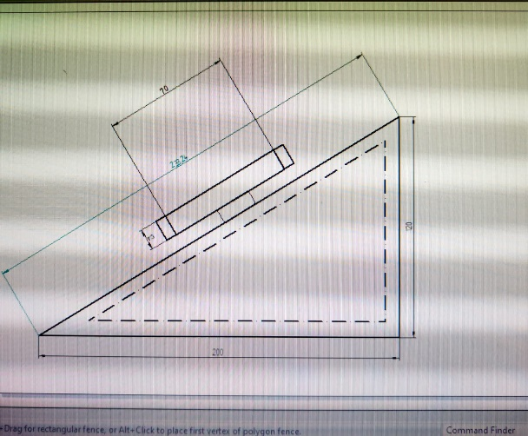

Fig 3.1 Side View

(App used is solid edge t4 for 2D)

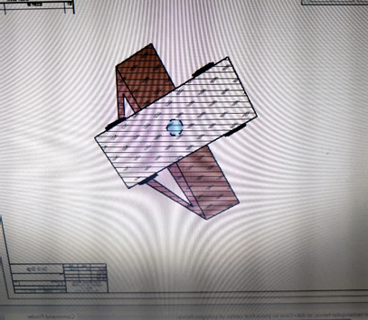

Fig 3.2 Top View (App used is solid edge t4 for 3D)

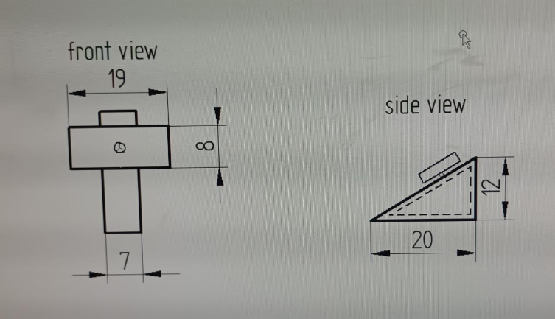

Fig 3.3 Front and Side view

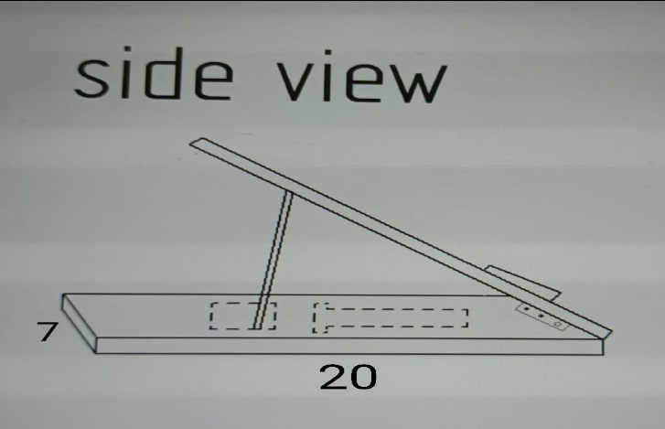

Fig 3.4 module 2

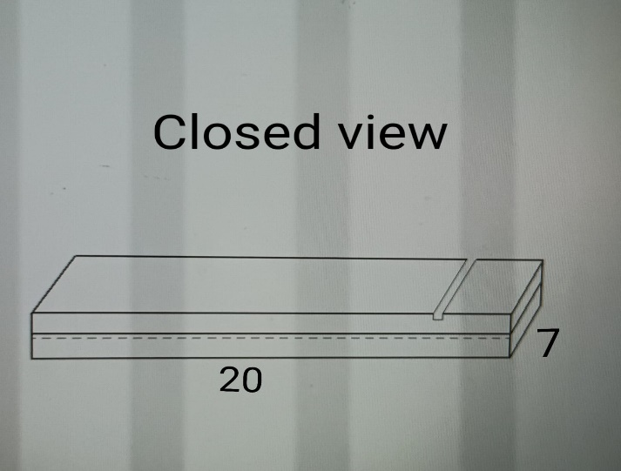

Fig 3.5 module 2

NOTE: Dimensions are in cm.

**3.2 MATERIAL**

Pine wood was preferred by our team members due to its durability and its advantageous properties. It is easy to shape and it has light weight which makes it easy for consumers to carry it around. Pine wood is easy to paste which helps in creating efficient design. It is easy to nail and screw. Although logically there are important differences depending on the species and where we buy it, the price of pinewood is low. Especially if we compare it with other wood. It is mainly due to its abundance. Cost of pine wood per square meter is inexpensive.



Fig.3. 4 Pine wood

## **3.3 DESIGN**

We wanted to design something compact, portable and unique. A triangular base is taken and the clamp is fixed onto its hypotenuse. We used wood for extra stability and strength. With the dimensions we found using Pythagoras theorem we designed our product by interacting with carpenter. There is a compartment present below the clamps which helps in storing electronic devices like ear phones, charger etc.

We designed another product using similar dimensions it is a compact version which makes it easier to travel. The design of this model is inspired by a pencil case, just like the pencil case the product we created is also easy to carry around.

**Chapter: 4**

**FABRICATION**

Our product is made of pine wood. Pine wood is light and durable, it is long lasting compared to other products like silicon, steel etc. Clamp is made of plastic in order to protect the phone from damage.



Fig.4.1 Cutting of wood



Fig.4.2 Nailing and screwing of wood

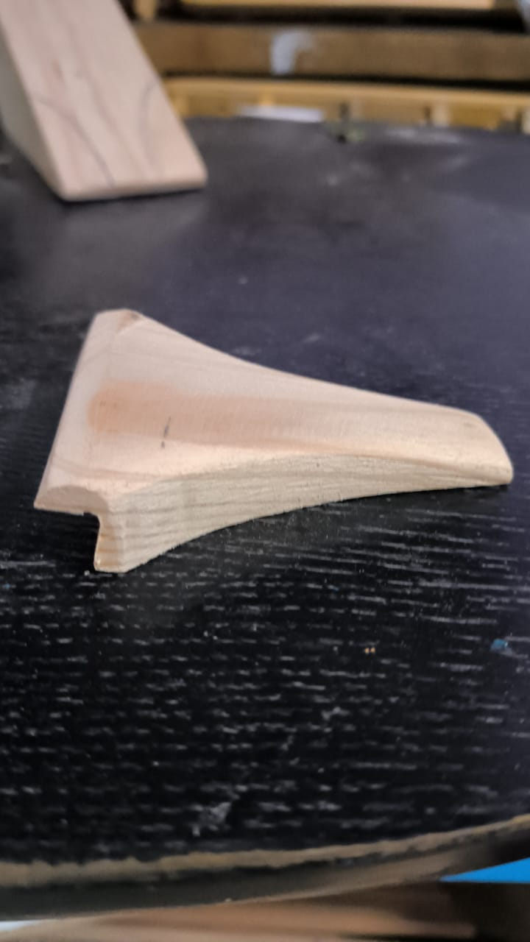

Fig.4.3 Wooden clamp

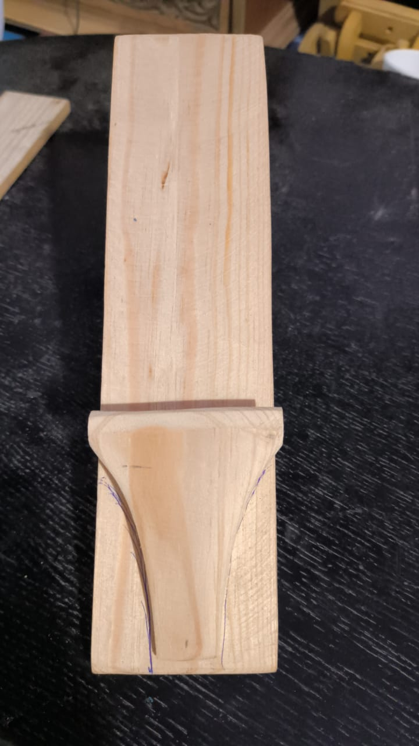

Fig.4.4 Front view of the model

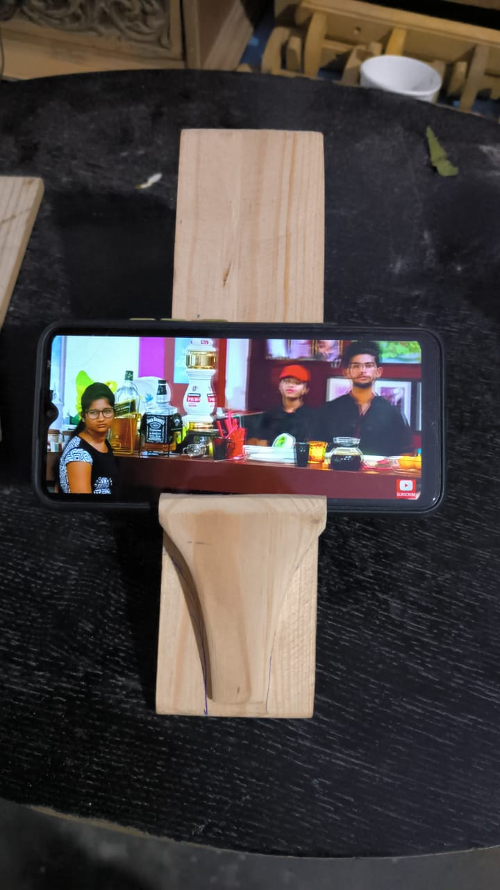

Fig.4.5 Testing for stability

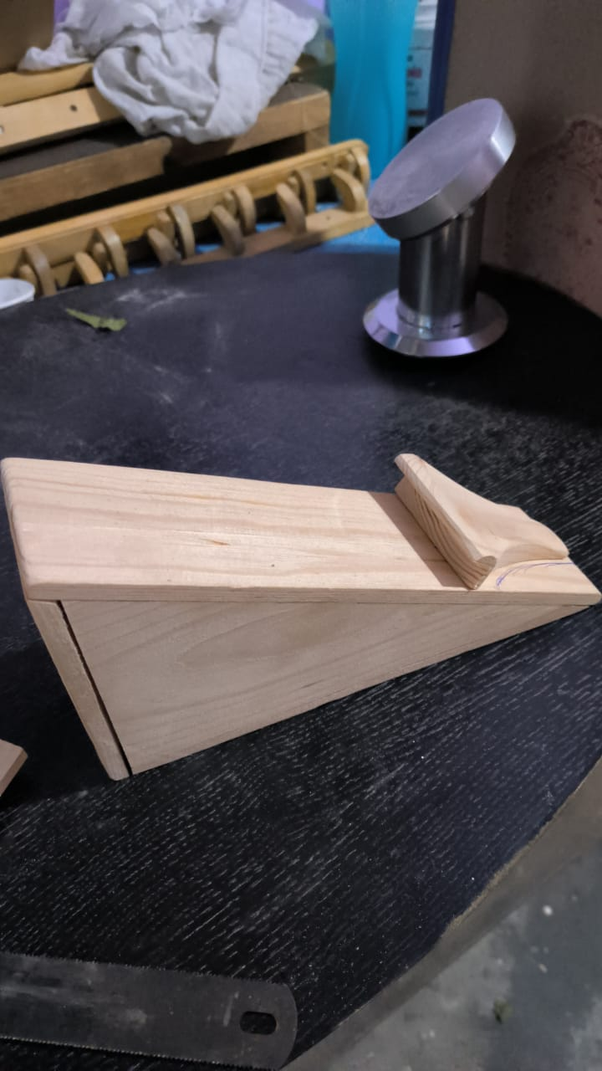

Fig.4.6 Side view of the model

**Chapter: 5**

**PROTOTYPE**

1.Select wood which is convenient for the product.

2.Measure it and cut it using a saw.

3.Scrape the wood to make it smooth, and to give it a proper texture.

4.Attach the wood using adhesives like sound43(helps in faster adhesion), fevicol etc.

5.Leave it to dry.

6.Blunt the edges to prevent from cutting your hand.

7.Give it a finishing polish.

8.The adhesive used is sound43.

9.The cutting was done using machine.

10.Natural polishing will be given for the product to bring show it's woody look

11.For the second model small hinges were used to make it foldable and portable.

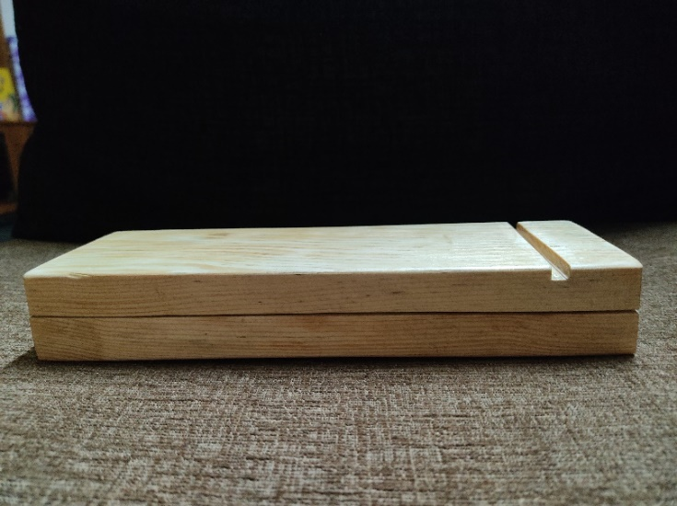

Fig 5.1 Model 2 in closed position

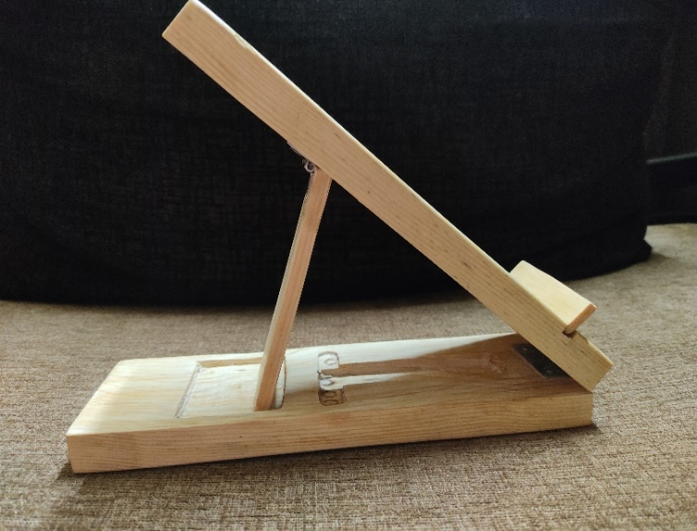

Fig 5.2 Model 2 in open position

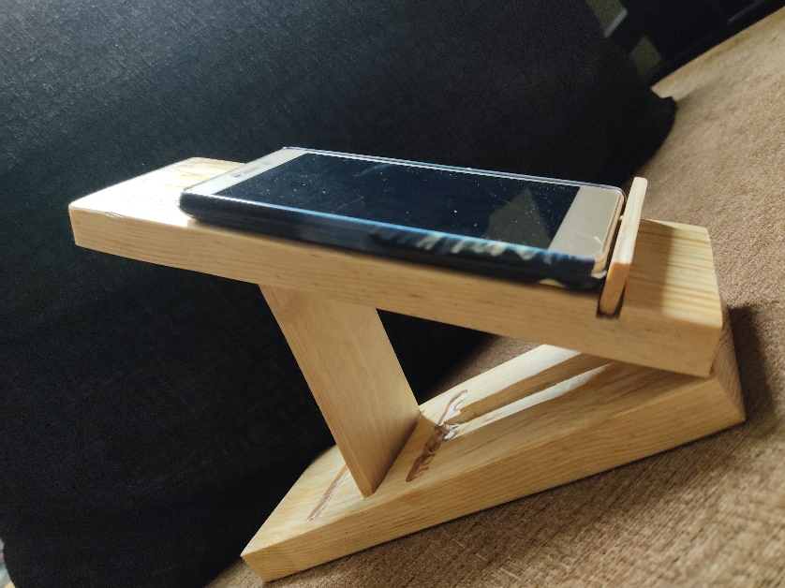

Fig 5.3 Model 2 with mobile



Fig 5.4 Model 1

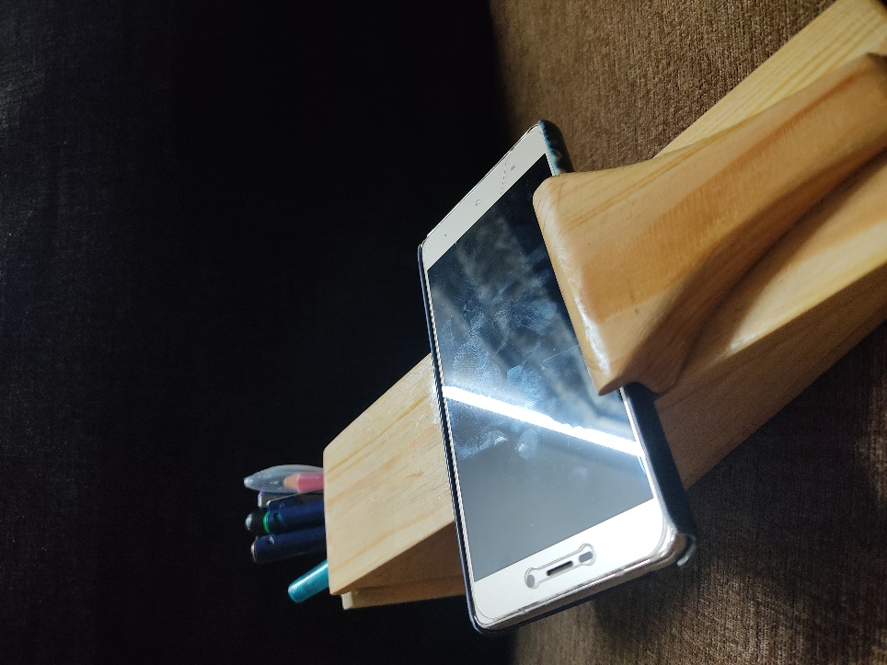

Fig 5.5 Model 1 with mobile and pens placed in the compartment

# 

**Chapter: 6**

# **Conclusion**

In today’s market there are many mobile holders but what makes our product unique is it has a compartment for electronic gadgets like earphones, charger etc. It is stable and durable. We used pine wood for our product which makes our product light and strong.

Both our models are unique the first model has a compartment inside which helps the user to keep electronic gadgets, pencils, pens etc. Our second model does not have an extra compartment like the first product but it is more compact compared to our first model. Therefore, according to the need of the consumer our products can be used.

**REFERENCE**

* Yuppienalle holder

<https://www.ikea.com/in/en/p/yuppienalle-holder-for-mobile-phone-grey-60503885/?gclid=Cj0KCQiAgribBhDkARIsAASA5bv567lw0_e7mQalGCJyAIUfVSKQ_ERZrtsvjH9QQifsCA4l0RsPufIaAmtEEALw_wcB>

* Krubbet holder

<https://www.ikea.com/in/en/p/krubbet-holder-for-mobile-phone-black-70531939/>

* ASTEE TRADING Wall mount holder

<https://www.snapdeal.com/product/mobile-phone-holder-stand-wall/6917529650202099471>

* Nbox holder

<https://lowpricesaree.in/product/nbox-universal-mobile-phone-stand-holder-mount-with-inbuilt-cable-organiser-for-phones-and-tablet-upto-17-78-cm-7-inch-black-earphone-not/>

* Maxbell holder

<https://aladdinshoppers.com/products/0637a_tiktok_vip_stand?variant=42205590913205&currency=INR&utm_medium=product_sync&utm_source=google&utm_content=sag_organic&utm_campaign=sag_organic>

* Skycell holder

<https://www.flipkart.com/skycell-bike-mobile-holder-stand-phone-mount-push-button/p/itm1f51509f9af7b>

* SDO holder

<https://arcus-www.amazon.in/SDO-Universal-Portable-Foldable-Holder/dp/B01CEZH9N4>

* Striff Ps2 mobile holder

<https://www.amazon.in/STRIFF-Mobile-Android-Samsung-OnePlus/dp/B07GXHC691>

* Pluggland holder

<https://www.ikea.com/in/en/p/pluggland-holder-for-mobile-phone-check-pattern-black-white-90518828/>

* Gravity design

<https://mycookwareshop.com/products/copy-of-bike-mobile-universal-bike-cell-phone-spider-bike-multi-use-mobile-holder-x-grip-motorcycle-handlebar-mount-smartphone-holder-black-1?_pos=10&_sid=beebc680f&_ss=r>